Piaggio Fly 150
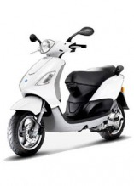
7,500 PTZ
The Piaggio Fly 150 is pure fun. Eye-catching style is just the beginning. Agile handling, superior craftsmanship, and cutting-edge technological performance make commuting as much fun as zipping to the café. Be an individual. Be free. Ride on!

Samsung - 40"" Class/1080P/120Hz/LCD HDTV
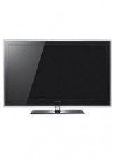
3000 PTZ
Bring high resolution television into your world and create your very own theater. Lightweight, stylish, and slim. Sharp, detailed images and Samsung's exclusive Touch of Color design. Be warned, you may never want to leave home again.

MacBook Air, 13-inch, Aluminum
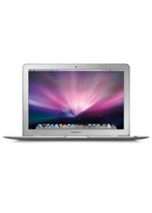
2500 PTZ
With faster processors and powerful graphics, MacBook Air is more than just remarkably thin. It’s the ultimate ultraportable. Weighing only 3.0 pounds, nearly as thin as your index finger, yet amazingly durable. Throw it in your bag then pull it out wherever you happen to go without a second thought.

MacBook Pro 13-inch - Aluminum
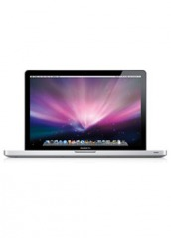
1500 PTZ
The classic Macbook Pro gets a makeover, with a faster processor, more storage, advanced graphics processing, wireless backup, and plenty of digital connections for your iPhone, iPod, camera, and other peripherals all encased in sturdy, and uber-stylish, aluminum.

MacBook 13-inch
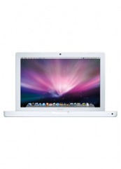
1000 PTZ
The classic Macbook gets a makeover, with a faster processor, more storage, advanced graphics processing, wireless backup, and plenty of digital connections for your iPhone, iPod, camera, and other peripherals.

Burton Blunt (147) and Burton Blunt (157)
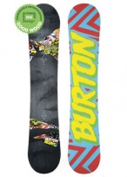
850 PTZ
Time to step up your game and get a real board. With V-Rocker technology, Cruise Control, a rocker design, and edges that are turned up and de-tuned, you will turn into a trick-landing master.

Burton Bullet (160) and Burton Bullet (164)
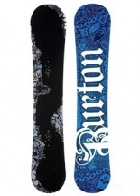
850 PTZ
Calling all beginners who want a quick launch to the next level. Get your cruise on on a board built for big boots and you'll be know as Master Shred in no time.

Burton Feather (144) and Burton Feather (148)
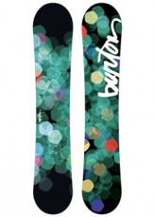
850 PTZ
This board is built for impatient beginners and immediate riders who want fast progression. In no time you'll be the envy of the unannointed.

Burton Mayhem (155)
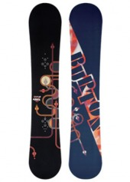
850 PTZ
Made for speed and decidedly not for the faint of heart. Go ahead and spray your way down the slopes, but don't get too carried away. Sooner or later, all that speed will have you mid-air.

Burton Seven (152)
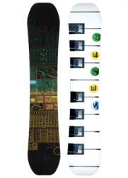
850 PTZ
This board is no joke. One of the most sought after around, it will elevate your to superstar status with its flashy look and park ripper moves.

HP Mini 110-1025DX
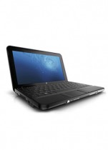
800 PTZ
Lightweight and portable, this netbook features a built-in webcam and wireless connectivity for fast and easy video chatting with friends and family.

3rd Gen iPod Touch 64GB
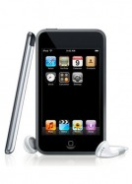
800 PTZ
The iPod touch just got an upgrade. Still all the games, apps, music, movies, and TV shows you want, but with even faster performance. Real-time 3-D graphics, 3-D positional sound, and Genius Playlists. Show your friends you are always ahead of the curve.

Dell Inspiron Mini 10 inch- Obsidian Black
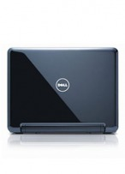
750 PTZ
This computer may be small, but it has huge powers - letting you surf the Web, chat with friends, stream video and upload photos to blogs or sites. Stay in touch as you stay on the go with this miniature marvel!

Dell Inspiron Mini 10 inch- Sunrise
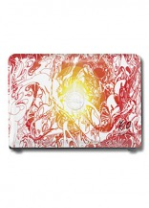
750 PTZ
This computer may be small, but it has huge powers - letting you surf the Web, chat with friends, stream video and upload photos to blogs or sites. Stay in touch as you stay on the go with this miniature marvel!

3rd Gen iPod Touch 32GB
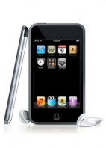
700 PTZ
The iPod touch just got an upgrade. Still all the games, apps, music, movies, and TV shows you want, but with even faster performance. Real-time 3-D graphics, 3-D positional sound, and Genius Playlists. Show your friends you are always ahead of the curve.

PSP GO - Black & White
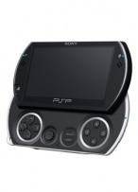
675 PTZ
Sleek and slim, this PSP packs a punch. Download games and movies directly, Skype, and show it all off with the crisp LCD screen. You'll be the envy of every gearhead with this slick little beauty. Versatile, portable, and above all, powerful.

Xbox 360 Game System Elite
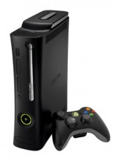
675 PTZ
Xbox 360® Elite is the premier console package with a massive hard drive, a high-definition multimedia interface (HDMI) port, and a premium black finish for the console. Get started with a black wireless controller, Xbox LIVE® headset, and a free Netflix trial all included.

PS3 Game System Slim- 120GB
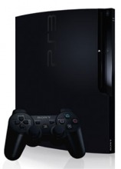
625 PTZ
120GB. A slicker, new body. A Blu-ray players go that's pretty hard to beat -- and that's before you even factor in the games. This is the kind of console that will take you to a whole new level.

2nd Gen iPod Touch 32GB
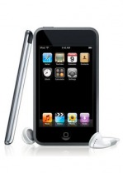
600 PTZ
All the games, apps, music, movies, and TV shows you want. Real-time 3-D graphics, 3-D positional sound, and Genius Playlists are just a few of the goodies you’ll find. You can even browse the web. How will you find time for anything else?

Amazon E-Gift Cards Cards France 450 Euros
500 PTZ
It's a jungle out there so treat yourself to a shopping spree at one of the world's greatest online stores. Create your own perfect package with the latest books, games or gear. Call the shots and treat yourself. You deserve it. You really do.

Amazon E-Gift Cards Germany 300 Euros
500 PTZ
It's a jungle out there so treat yourself to a shopping spree at one of the world's greatest online stores. Create your own perfect package with the latest books, games or gear. Call the shots and treat yourself. You deserve it. You really do.

Amazon E-Gift Cards UK 300 GBP
500 PTZ
It's a jungle out there so treat yourself to a shopping spree at one of the world's greatest online stores. Create your own perfect package with the latest books, games or gear. Call the shots and treat yourself. You deserve it. You really do.

Apple TV
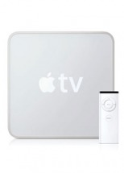
500 PTZ
HD movie rentals, HD TV shows, and more. All coming to turn your widescreen into a digital entertainment hub. And it will be become the place to show off you digital photos set to music.

Canon Elph Powershot SD1200 IS - Blue & Silver
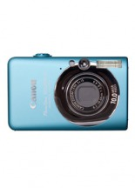
500 PTZ
When a camera puts a smile on your face the moment you hold it, imagine how great you'll feel when you see your first pictures! Exuberant color and the sculptured style of Canon's famed ELPH series. Fun, smart and a style that follows you everywhere.

DSC-W220/P Sony Cybershot - Pink
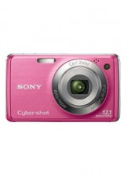
500 PTZ
It's never been easier to capture happy faces. Simply choose the Smiley Face icon and the camera does the rest. Soon you'll be impressing the world with your photo taking abilities.

Apple Time Capsule
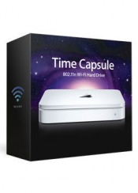
500 PTZ
Here's your saving grace. A revolutionary back up device that works wirelessly. Protect your beloved songs, photos and files and never worry about a crash again, all with this magnificent and compact invention from Apple.

Marc Jacobs - Picnic Hobo
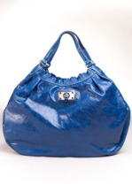
500 PTZ
Here's your chance to own the must-have purse from the coolest designer around. Glossy and textured leather. The MJ shiny signature turnlock make this bag irresistible.

Black Epiphany Paintball Gun
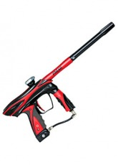
450 PTZ
New features equal improved consistency for the intermediate. Adjustable volume fire chamber for velocity stability at high rates of fire. Super light magnesium alloy body meant for the agile.

Beatles RockBand Bundle LTD Edition - PS3, Xbox 360 & Wii
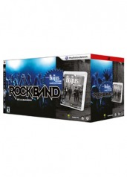
450 PTZ
The world’s leading music game meets the greatest band in history! The Beatles™: Rock Band™ gives fans what they’ve been waiting for: a chance to experience the Beatles’ as an insider. You won’t just watch and listen as the Beatles make rock history, create landmark records and conquer the world—for the first time, you’ll be part of the band.

Apple/Nike Active Pack
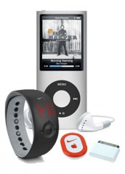
450 PTZ
Everything you need for the ultimate running experience. A silver Nano, a Nike iPod Sport Kit, and a Nike iPod Watch Remote combine for the ultimate in motivation by music. There just might be a marathon in your future.

5th Gen iPod Nano 16GB - Black, Blue, Green, Orange, Pink, Purple, Red, Silver & Yellow
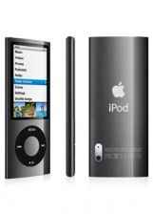
425 PTZ
Get your paws on the newest, hottest Nano. Rock out to your playlists - and FM radio. And start shooting with a built-in video camera. Same new features and functions that make it easier than ever to create great playlists. A built-in accelerometer shuffle your songs. Share photos, watch movies, play games, too

Ripstick Classic - Blue, Green, Pink & Silver
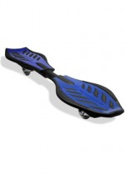
375 PTZ
Just twist and go! The RipStik Caster Board brings the carving thrill of surfing and snowboarding to dry land. Its unique twisting motions deliver ultimate control and an unbelievably smooth ride.

Beatles Rockband Value Pack - PS3, Xbox 360 & Wii
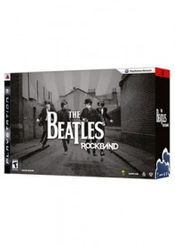
375 PTZ
Immerse yourself in the music and artistry of the Beatles. Show off your skills on guitar, bass, drums or vocals as you jam your way through hits that span the length of the Beatles' impressive career. Combine up to three microphones to make your own Beatles style harmony.

DSi Game System - Black
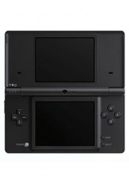
375 PTZ
Nintendo DSi, the third version of the world's best-selling portable video game system takes it to the next level by transforming the way you access, experience, create and share content!

T3 Bespoke Labs Special Edition Evolution Professional Iconic Ceramic Tourmaline Hair Dryer
350 PTZ
Dry your hair 60% quicker with the Limited Edition Bespoke Labs T3 Tourmaline Ionic Featherweight dryer. The compact design delivers incredible power and weighs less than one pound!

Ray Ban Orignal Wayfarer - Red, Black, Yellow, Blue, Tortoise, White & Orange
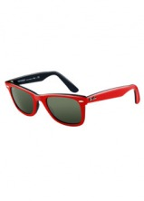
335 PTZ
Reach iconic style and status when your wear the world's best-selling sunglasses. This distinct and unmistakeable design is coveted by Hollywood celebs. Add your own personal flair and chose your signature color.

SP-1 Paintball Gun
325 PTZ
A fresh take on tactical. With military styling and ultra rugged construction, call this built for speed and made to last. Functions equally well in both cold and warm weather.

iHome Docking Station
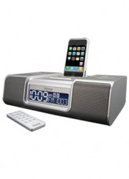
325 PTZ
Wake up to your own music. The iHome universal dock is an AM/FM clock radio that charges and plays your iPod and iPhone. A line-in jack even lets you play CD, MP3 players, and other audio devices.

2nd Gen iPod Touch 8GB
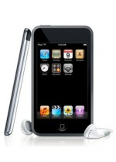
325 PTZ
All the games, apps, music, movies, and TV shows you want. Real-time 3-D graphics, 3-D positional sound, and Genius Playlists are just a few of the goodies you’ll find. You can even browse the web. How will you find time for anything else?

Sony Portable DVD Player
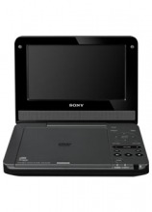
300 PTZ
The beach or the pool, the car or the plane. Comedy or drama, action or romance. Take your movies everywhere you go with this portable entertainment center.

Farouk Chi Ceramic Flat Iron 1 - Black & Pink
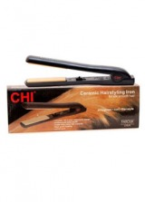
300 PTZ
Forget that pricey salon blow-out. You can do it all - from straighten to curl or flip and style. And get shiny hair instantly. Looking good girl!

4th Gen iPod Nano 8 GB - Black, Green, Orange, Pink & Silver
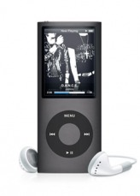
300 PTZ
You are your own DJ. The iPod Nano lets you rock out even more, with new features and functions that make it easier than ever to create great playlists. A built-in accelerometer shuffle your songs. Share photos, watch movies, play games, too.

Amazon E-Gift Cards Cards France 50 Euros
250 PTZ
It's a jungle out there so treat yourself to a shopping spree at one of the world's greatest online stores. Create your own perfect package with the latest books, games or gear. Call the shots and treat yourself. You deserve it. You really do.

Amazon E-Gift Cards Germany 50 Euros
250 PTZ
It's a jungle out there so treat yourself to a shopping spree at one of the world's greatest online stores. Create your own perfect package with the latest books, games or gear. Call the shots and treat yourself. You deserve it. You really do.

Amazon E-Gift Cards UK 50 GBP
250 PTZ
It's a jungle out there so treat yourself to a shopping spree at one of the world's greatest online stores. Create your own perfect package with the latest books, games or gear. Call the shots and treat yourself. You deserve it. You really do.

12 Month Microsoft Xbox Microsoft Gift Card
250 PTZ
Points are the easiest way to pay and play. You can use them to buy loads of Xbox® extras. The hardest part will be deciding what to spend them on.

$50 iTunes Gift Card
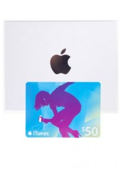
250 PTZ
There might be nothing better than knowing you can chose 50 new songs for your IPod or IPhone. Your music library is about to expand exponentially.

Nintendo Wii with Wii Sports
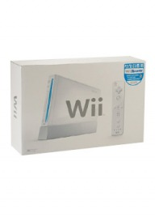
250 PTZ
You gotta have one to play! Wii connects you like never before. Play games. Make caricatures. Play music. Shop. Get fit. You can even check the weather! The Wii is super intuitive -- people of all ages and skill levels can play together. But it's not just a Wii, its the games you need to get playing immediately. Four that run the gamut - boxing, baseball, tennis, and golf. And up to four can compete at once, so invite your friends and put on your big boy pants.

Fitness Plus with Balance Board - Wii
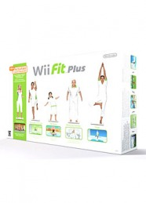
250 PTZ
Take the work out of workout as you skateboard, golf and kung fu it up all in the privacy of your own home. Customize your workout, and include friends, family and even pets. Exercise your right to be strong, healthy and super amped as you move your body with the latest fitness craze!

Nintendo Wii Fit
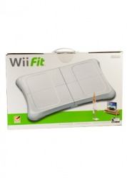
250 PTZ
Get off the couch and into the action with Wii Fit! From Hoola Hoop to Snowboard Slalom getting fit has never been so much fun. Train, tone, and stretch with four categories of fitness activity: Strength training, Aerobics, Yoga, and Balance Games.

Apple Mobile Me
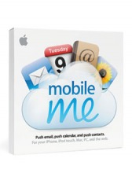
225 PTZ
Who doesn't need to simplify their life? Your iPhone, Mac and PC, all in perfect sync. Your very own online "cloud" automatically pushes new email, calendar contacts, and events to all of your devices. And no docking required

3rd Gen iPod Shuffle - Black, Blue, Green Pink & Silver
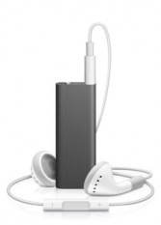
200 PTZ
Small gets smaller and even more amazing. 4GB storage for 1000 songs. The first music player that talks to you, so easy you can use with your eyes closed.

Flip Video Ultra HD
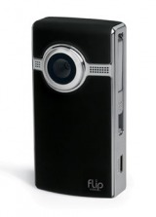
200 PTZ
Lights, camera, action! Take the stylish Flip Video Ultra HD anywhere you go. Shooting and sharing video doesn't get any easier than this.

Guitar Hero 5 Guitar Bundle - PS3, Xbox 360 & Wii
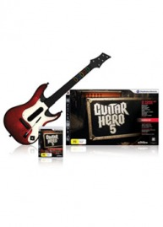
200 PTZ
Guitar Hero 5 continues Activision's music rhythm series with an expanded lineup of 85 songs from 83 artists. While the basic format is identical to 2008's Guitar Hero: World Tour, with each song supporting a singer, drummer, lead guitar, and bass, a number of changes have been added to enhance its pick-up-and-play appeal.

PSP - Ratchet & Clank Bundle
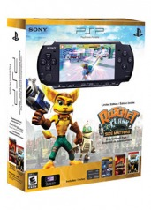
200 PTZ
Play thrilling games, movies, music, connect to the Internet, talk to friends around the world with Skype using a built-in microphone. With the PSP system's all-around new dazzling widescreen LCD screen, the PSP system is truly the only place to play.

PSP - Rock Band Bundle
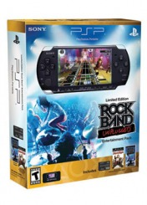
200 PTZ
The stadium is in the palm of your hand. Pick a song or make a set list. Customize your band and go on a World Tour. Download songs. Includes original masters from Weezer, The Who and more.

iPod Dock + Karaoke System
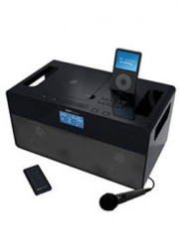
200 PTZ
Streamlined style and big sound make this karaoke system something to sing about. Play all your favorite music with iPod docking. Bring the party anywhere with audio and video outlets that connect to any TV or sound system.

G-Shock Baby-G Chaton - Orange
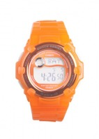
200 PTZ
A style meant only for the most fashionable of females - but be warned that you will light up any room your enter. With stunning "Chaton style" bezels and molded resin bands.

G-Shock G-Lide - Blue, Green, Black & Red
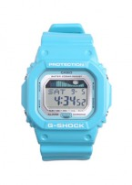
200 PTZ
Attention surfers and extreme sports enthusiasts. Want to know the latest surf conditions? Check. Want to know the moon phase? Check. Grab your board and go. With this watch you are always ready for the next big wave.

G-Shock LRG X G-Shock 6900 - Yellow
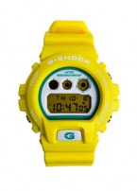
200 PTZ
Kill time in sweet style with this sunny timepiece. A limited edition beauty, tough and tech-savvy.

G-Shock Luminous - Pink & Yellow
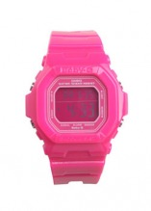
200 PTZ
A watch with Hollywood style. Compete with any starlet when you sport a watch so colorful and luminous you'll feel like are on your own red carpet.

G-Shock Mudman G9000 - Black, Blue & Red
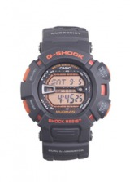
200 PTZ
Rugged and extreme. Get down and dirty with a super tough watch that melds function and fashion for the adventurer's lifestyle.

G-Shock Tough Culture - Yellow & White
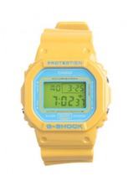
200 PTZ
Bold style not meant for the faint of heart. Worn by A-Listers like Kanye West and Spike Lee. Let everyone know you are just as tough.

Skullcandy Full Metal Jacket - Black
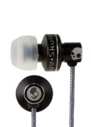
175 PTZ
Tiny, high-end, named for a bullet with good reason. With metal housing and well-endowed speakers, these bass-rich, noise isolating earbuds will rock your world.

SkullCrush - Abel Money & Snoop Dogg Blue
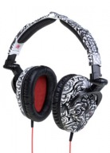
175 PTZ
Headphones are not just sweet headphones, but a totally rad accessory. With DJ style swiveling ear cups, these pack a monster punch that will help you shut out the world - or use your turntable to turn it up.

Hi-Lo Combination Converter/Transformer Kit
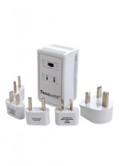
150 PTZ
Stay current with the magic of this easy-to-use converter. This transformer can handle up to 1875 watts, and has an adaptor that can handle almost any outlet known to man. Take it on your travels, and keep your essential electronics charged and ready to go.

Razer eXactMat- Duo Precision Gaming Surface
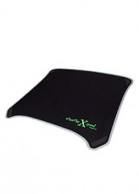
150 PTZ
Switch between speed and control sides with this extremely tough and always precise pad. Rest your wrists as you rule!

Second Generation iPod 1 GB Shuffle - Green, Silver
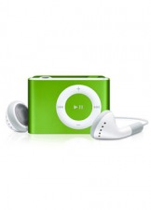
150 PTZ
Clip on your shuffle and take up to 240 songs with you anywhere. Create a music mix with the flip of a switch, and then flip it back to play your selected playlists.

Skullcandy Lowrider - Black, Brown Stripe, Glen Plaid, Pink Print & White Print
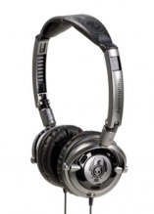
125 PTZ
Lowriders are not just sweet headphones, but a totally rad accessory. With DJ style swiveling ear cups, these pack a monster punch that will help you shut out the world - or use your turntable to tune it in.

Skullcandy Titan - Black & Chrome
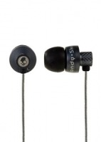
125 PTZ
How could something so small make it feel like you and your music are the only ones in the room? Precision-cut metal housing encapsulates a sound coming from deep within. You might get lost in your own world, but these won't go unnoticed.

Orange Amps Micro Crush Amplifier
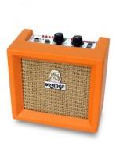
125 PTZ
Fresh squeezed sound! Legendary Orange amps deliver bold retro styling and pure tone. From Weezer to Wilco, find out why the best musicians in the world love Orange.

Star Wars Clone Wars Republic Heroes - PS3, Xbox 360, PSP & DS
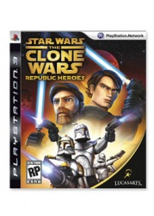
100 PTZ
Let the force be with you as you lightsaber your way through Separatist droids. For the first time ever, players can fight as their favorite Jedi and clone troopers as they aim to stop a mysterious techno assassin’s destructive plot. Get your Jedi on in this intergalactic spectacle!

Batman Arkham Asylum - PS3 & Xbox 360
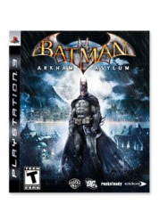
100 PTZ
Original adventure of fast action and large scale combat sequences from a close third-person perspective in a dark, survival horror-styled setting. In addition to the Joker and his brilliant aide in evil, Harley Quinn, Batman faces other super-powered asylum patients, including Bane, Killer Croc, Zsasz.

Call of Duty: World at War - Xbox 360
100 PTZ
These are the final, harrowing days of World War II. The Axis powers advance on multiple fronts from Europe to the Pacific. The enemy knows no retreat and no surrender. Can you survive as they unleash their final deadly and desperate attacks?

Call of Juarez: Bound in Blood - PC
100 PTZ
The Old West, 1864. In order to save their family, the McCall brothers will kill anyone who stands between them and the legendary Gold of Juarez. But when money and women test their bond as brothers, will the blood they share prove to be thicker?

Demon's Souls Standard Edition - PS3
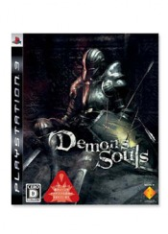
100 PTZ
Are you strong enough for the ultimate hardcore RPG challenge? Test your powers against some seriously evil villains in the game that’s already wreaking havoc worldwide. Don’t be reined in by one single path – in this revolutionary game you’re free to create your journey. Slay some demons in a game that can only be described as epic!

Dirt 2 - PS3, PSP
100 PTZ
As the sequel to the acclaimed racer of 2007, get set to take off-road racing games to a new level. Packed with a wide new benchmark technology, thrilling new race types, big event atmosphere, stunning locations, a new breed of off-roading heroes and a peerless line-up of super-charged speed machines, this isn't your standard off-road racing game. It is the new standard.

EA SPORTS Fight Night Round 4 - Xbox 360
100 PTZ
Float like a butterfly and sting like a bee when you fight in the ring with legends like Muhammad Ali, George Foreman and Mike Tyson. Physics-based gameplay recreates the sport's incredible speed, accuracy and power like never before.

Final Fantasy: Dissidia - PSP
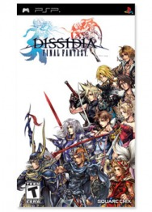
100 PTZ
Cosmos, the goddess of harmony. Chaos, the god of discord. Reigning from distant realms, the two gods had gathered warriors from all lands to lead them in savage war. Cosmos and Chaos were of equal strength. It was believed the conflict would last forever. However, the balance is now broken.

Game Party 3 - Wii
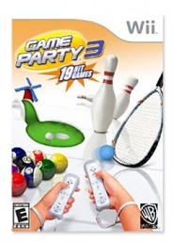
100 PTZ
Have some good, clean fun with all the rec room classics. Get some shuffleboard skills, throw your darts in the air, or become a croquet master . Bring along your friends and family, and have a giddy gaming party. We know you've been wondering what the fuss is all about, so check out the game that has everyone clamoring for a turn at the console.

God of War: Chains of Olympus - PSP
100 PTZ
The world has plunged into darkness. The Gods send Kratos to the underworld. In a terrifying quest, he must face the most feared creatures of Greek mythology. A prequel to the other games in the God of War series.

Gran Turismo - PSP
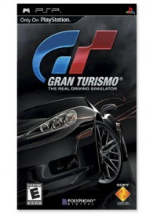
100 PTZ
Speed devils unite: Gran Turismo is finally available for PlayStation. Thrills abound as you take on the legendary race with state-of-the-art graphics, taking your pick from 800 cars and 35 tracks. Get it while you can!

Grand Theft Auto IV - Xbox 360, PS3 & PC
100 PTZ
Welcome to Liberty City’s underworld of crime, gangs, and serious corruption in this “open-world” driving and shooting game. Follow Niko Bellic as he gets caught up in danger and destruction in one of the highest rated games of all-time.

Grand Theft Auto Vice City Stories - PSP
100 PTZ
Vice City, 1984. Opportunity abounds in a city emerging from the swamps, its growth fueled by the violent power struggle in a lucrative drugs trade. The choice is stark: build an empire or be crushed.

Guitar Hero Aerosmith - PS3 Game
100 PTZ
Join the Bad Boys of Boston and rock and roll your way through more than 40 of the band’s greatest hits. Get behind-the-scenes footage of how this legendary group rose to fame, and learn some of their signature moves.

Halo 3 ODST - Xbox 360
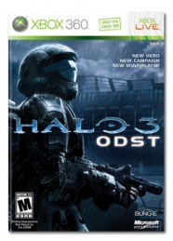
100 PTZ
Here's XBox's best-selling game, a ferocious, spectacular add to your collection. Are you ready to take on the Covenant onslaught in the new cooperative multiplayer mode, Firefight? Then, get ready to join the Orbital Drop Shock Troopers and fight for your life against the vicious, relentless wave of of enemies.

Hearts of Iron III - PC
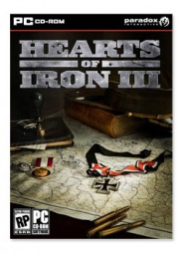
100 PTZ
The most detailed World War II game ever made. Play as any nation and choose any front. Deep diplomacy and real historical figures allow you to participate in this epic struggle – and change the course of history – like never before.

Jillian Michaels Fitness Ultimatum 2010 - Wii
100 PTZ
Feel the burn! Sign up for celebrity trainer Jiliian Michael's boot camp on a rugged Pacific island. Fast-paced and high intensity, this workout is geared to get you in amazing shape without spending a year at the gym. Includes personal instruction, as well as a personalized program and calendar. Soon, you'll be as agile as you are adorable.

Killzone 2 - PS3
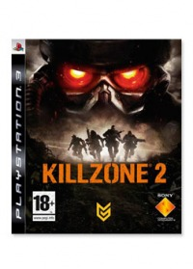
100 PTZ
The Interplanetary Strategic Alliance takes the fight to the bad guys - all the way to their home planet. Get a cinematic experience, blending Hollywood-style sequences with free form player action. This game will keep you coming back for more.

KillZone: Liberation - PSP
100 PTZ
Two months after the events of Killzone, most of southern Vekta is still under Helghast control. The rules of war have been cast aside with the Helghast General, Metrac, employing brutal measures in order to seize the initiative and strengthen his position further.

Madden NFL 2010 - PS3, Xbox 360, Wii & PSP
100 PTZ
A video game staple for two decades, EA's best-selling football series rumbles onward with Madden NFL 2010. Online franchise play includes authentic NFL schedules, transactions, live drafts, adjustable depth charts, and stat tracking.

Mario & Sonic at the Olympic Games - DS
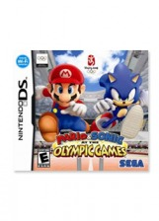
100 PTZ
Two of the world's most beloved icons have joined forces to star in the Olympic Games. This momentous moment marks the first time these two reknowned stars have appeared together in a game.

Marvel Ultimate Alliance 2 - X360, PS3, Wii, PSP & DS
100 PTZ
The Marvel Universe is being torn apart. The Superhuman Registration Act becomes law and Super Heroes must register as weapons of mass destruction, becoming licensed government agents. As Civil War is stirred, Iron Man leads the Pro-Registration side while Captain America spearheads the stand on Anti-Registration. The enemies you battle and the missions you accomplish depend on which side you choose.

NBA Live 2010 - 360 & PSP
100 PTZ
Calling all ballers! Here's your chance to join the hoops elite and prove you've got game. NBA 2K10 gives you the chance to show your stuff at both ends of the court. Shut down teams and shadow your opponent's every move, deny position off-ball, and even select how you want to contest shots. A must for any sports fan who wants to play the funnest game on the market.

NBA 2K10 - PS3, Xbox 360, Wii & PSP
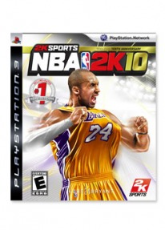
100 PTZ
Calling all ballers! Here's your chance to join the hoops elite and prove you've got game. NBA 2K10 gives you the chance to show your stuff at both ends of the court. Shut down teams and shadow your opponent's every move, deny position off-ball, and even select how you want to contest shots. A must for any sports fan who wants to play the funnest game on the market.

NHL 2010 - PS3 & Xbox 360
100 PTZ
Take to the ice as the deafening sound from a towel-waving crowd ignites an arena while the hope of an entire franchise and the dreams of thousands of fans rest upon your shoulders. Using a physical style or playing with finesses, prove you’re tough enough to battle the most skilled hockey players in the world in your pursuit of the ultimate prize—the Stanley Cup Championship.

NHL 2K10 - Wii
100 PTZ
Take to the ice as the deafening sound from a towel-waving crowd ignites an arena while the hope of an entire franchise and the dreams of thousands of fans rest upon your shoulders. Using a physical style or playing with finesses, prove you’re tough enough to battle the most skilled hockey players in the world in your pursuit of the ultimate prize—the Stanley Cup Championship.

Naruto Shippuden: Legends Akatsuki - PSP
100 PTZ
Anime alert! Get in touch with your inner ninja as you battle enemies in a vivid and lush 3D world. Run the Akatsuki organization, go searching for Gaara, or find who the best ninja is by battling against a friend or the computer in one-on-one fights. Jujutsu forever!

Naruto Shippuden: Ninja Destiny - DS
100 PTZ
Naruto has finally returned home to the Hidden Leaf Village after spending two and a half years training with one of the Legendary Sannin, Jiraiya. Armed with more ninja skills than ever before, Naruto comes to find out the friends he left behind have also become more powerful. Unbeknownst to them, their skills are about to be put to the test. Covering the first two story arcs of the new NARUTO Shippuden series, players will fight head-to-head matches as Naruto and his friends continue their quest to save what's most important to them: their friendships.

Need for Speed Shift - Xbox 360, PS3 & PSP
100 PTZ
Get ready to Shift your game into high gear! Built by racers for racers. An authentic and immersive driving experience, replicating the true feeling of racing high-end performance cars like never before. Players are thrust into the heart of the action with immersive and exciting features including a stunningly realistic first-person cockpit view camera and an all-new crash mechanic, providing an unrivaled sensation of the speed and feeling of racing a car on the extreme edge of control.

New Super Mario Bros. - DS
100 PTZ
Go old school with Luigi and Mario. Everything that makes this game a classic is here: Super Mushrooms, Koopa shells, and the famous Ground Pound (better known as the “butt bounce”). New worlds, new power-ups, and a multi-player mode keep things fresh.

Pokémon Platinum - DS
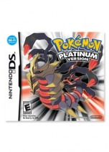
100 PTZ
Battle nefarious Team Galactic in the most challenging Pokémon adventure yet. Confront a new Battle Frontier. Explore the enigmatic Distortion World as it suddenly materializes. Discover new forms -- including the legendary Giratina's Origin Forme.

Professor Layton and the Diabolical Box - DS
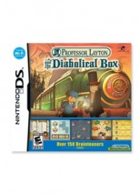
100 PTZ
The dapper professor is back with another mystery to unravel, more eccentric individuals to meet, and, of course, more puzzles to solve. With more and varied locations, Professor Layton and the Diabolical Box delivers more of the same classic mindbenders - all with a side of adventure.

Prototype - Xbox 360
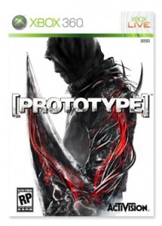
100 PTZ
Shape-shifter Alex Mercer is a man without memories, tied to a conspiracy he does not understand. As a viral epidemic rages through Manhattan and turns it into a war zone, he must survive and discover the true nature of his powers.

Saw - Xbox 360 & PS3
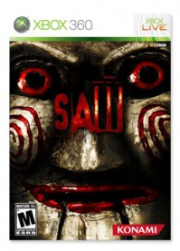
100PTZ
It's you against Jigsaw in this freak show. Save Amanda from Traps of Lethal Cunning. But it's not just gore and horror here - there's also some serious puzzle solving and navigation required. Mystery and terror prevails, as you fight to the finish.

Shaun White Snowboarding - Xbox 360
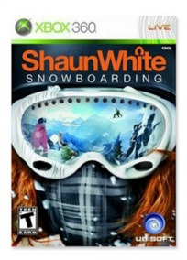
100 PTZ
Snowboard in total freedom. Developed with Olympic Gold Medalist Shaun White – the most successful snowboarder in the history of the sport. Ride your way: express yourself with tricks, riding styles, and highly customizable avatars.

Sports Resort with motion plus - Wii
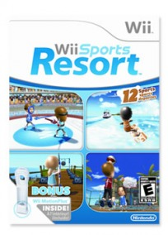
100 PTZ
An immersive, expansive active-play game that includes a dozen fun resort-themed activities. Easy to pick up and play, but deeper levels of play sure to challenge even the most experienced gamers

Transformers: Revenge of the Fallen - PS3
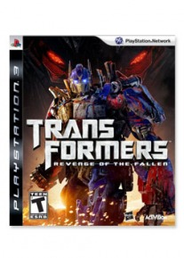
100 PTZ
Which side are you on? Become an Autobot or a Decepticon and use your power to save – or destroy -- humanity. Instantly switch between Robot, Vehicle, and Weapon modes as you fight your way through intense missions where every second counts.

UFC 2009 Undisputed - Xbox 360 & PS3
100 PTZ
Step into the Octagon and get the submission. Command the fight with photorealistic fighters who breathe, sweat, and move like the real thing as you develop the moves and attitude to win a place in the UFC Hall of Fame.

World of Warcraft - PC
100 PTZ
Want to adventure with 8 million players? The ravaged world of Azeroth must rebuild its shattered kingdoms against new threats and you can be part of the fight in this massive multi-player online game.

Bare Minerals Tutorial - Eye Lining, Foiled Eye, Rocker Eye & Smoky Eye
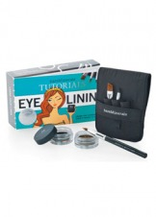
85 PTZ
It's about time you learned your lines. The subject today is eye lining—this kit is your personal beauty coach for learning lines like a pro and delivering a flawless eye-opening performance.

Tracy Matthews Gold Cuff, Alex & Ani Gold Crystal Chanel Bangle & Silver Bangle, House of Harlow Palladium Thick Stack Bangle & Rose Gold Thick Stack Bangle
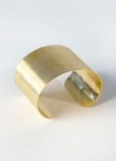
85 PTZ
Tracy Matthews designs are inspired by an unexpected mix of art fashion and color. This timeless gold cuff pairs vintage personality and natural simplicity. Effortlessly bridging casual and polished - you’ll find a million ways to shine in this graceful cuff.

Frederic Fekkai & Protein Rx Complete
75 PTZ
Dull hair transforms into lustrous locks with this bestselling treatment from celebrated stylist to the A-list. Fragrant and restorative - this set will make sure you shine!

HallWay notification for Santiago Mauro
85 PTZ
"Inside Out" is a behind-the-scenes coffee-table book about Ruffian designers Brian Wolk and Claude Morais written with Style.com editor Nicole Phelps. The photo-heavy tome chronicles the creation of the duo's spring and fall 2008 collections - from sketches and fittings to runway shows.

Essie Cuddle with Color Kit & Opi Senoritas Nail Collection
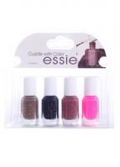
75 PTZ
Essie's new fall collection will perfectly accessorize this season’s exhilarating and uplifting styles. Each color will compliment any outfit -- whether it's gothic chic or shredded jeans.

Baggu Bags With Lots of Colors and Designs
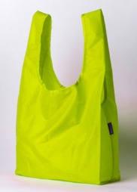
50 PTZ
This adorable tote is a favorite of fashionistas everywhere. It’s also extremely eco-friendly and made of lightweight recycled nylon. It's an alternative to the tired old plastic grocery bag. Look great and save the planet all at once!

Dylan's Candy
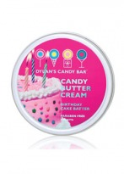
50 PTZ
Celebrate everyday like it's your birthday with a scent reminiscent of icing and sprinkles. A creamy, whipped texture that will sink into your skin and make you feel like you are the life of the party.

USB Flash Drive - Beetle - 2 GB With Lots More Designs
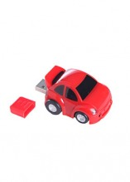
40 PTZ
Transport your computer memory into this Beetle-style mini racer.

Abolisher iPhone 3G Skin with Lots More Designs
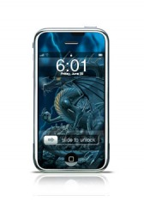
35 PTZ
Express yourself with a blue dragon as you protect your iPhone from daily abuse. Easy to use -- reposition at will. No annoying air bubbles! Afraid of commitment? Just peel it off. Goo-free removal!

